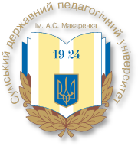
Ministry of Education and Science of Ukraine
Sumy State Pedagogical University named after A.S. Makarenko
Institute of Pedagogics of NAPS of Ukraine
Institute of Pedagogical Education and Adult Education of NAPS of Ukraine
Ukrainian Association of Educational Researchers
Borys Grinchenko Kyiv University
Sumy State Regional Administration
Sumy Regional Institute for Postgraduate Pedagogical Education
Berdyansk State Pedagogical University
Poltava National Pedagogical University named after V.G. Korolenko
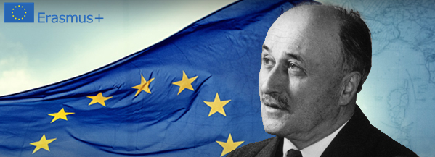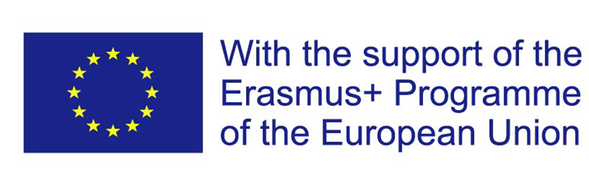
INFORMATION LETTER
Dear colleagues,
We are inviting you to participate in the V-th International Scientific Practical Conference «Innovative Development of Higher Education: Global, European and National Dimensions of Changes» which will be held on April 23-24, 2020 on the basis of the Educational and Scientific Institute of Pedagogy and Psychology of the Sumy State Pedagogical University named after A. S. Makarenko.

Thematic directions of the conference:
- Strategies of innovative development of higher education in Ukraine, EU and the world.
- Innovations in doctoral training in educational/pedagogical sciences: Ukrainian, European and world experience.
- Organizational and pedagogical support of innovative development of higher pedagogical education in Ukraine, EU and in the world.
- Strategies and innovative technologies of the training of high school teachers.
- Professional training of innovative development managers of higher education in Ukraine, EU and in the world.
- Psychological basics of innovative development of higher education.
- Innovations in the training of specialists in preschool and primary education in the context of the implementation of the concept «New Ukrainian School».
- Innovations in the educational activity of educational institutions in the context of the implementation of the concept «New Ukrainian School».
- Innovative technologies of vocational training of social workers in modern society.
- Innovations in the professional training of specialists in correctional and inclusive education.
The program of the conference includes: plenary meeting (session), work of the sections, social program. Participants’ registration is from 9:00 till 10:00 on April 23th, 2020 in the foyer of the main building of Sumy State Pedagogical University named after A.S. Makarenko.
Languages of the conference – Ukrainian, English, Polish.
Conference participants are invited to publish materials in the form of:
• conference paper in the conference proceedings;
The conference papers should be submitted till 20.03.2019 and will be printed before the conference in the conference materials collection in electronic form.
The conference papers are accepted in the Ukrainian, English, Polish languages. Electronic version is 3–5 full pages of A4 format MS Word, *doc, *rtf extension, 14 point Times New Roman, the last page more than 75% filled. Margins: left, right, upper, lower – 2 cm. The text should be typed 1.5 spaced. The indention of a paragraph is 1.25 cm. Do not archive, apply forced hyphenation, and disable editing. In the upper right corner put the first and last name(s) of the author(s), lower – scientific degree, position, below it – organization. The title should be capitalized, apply center alignment. The file name should contain author’s last name, e.g. Petrov_tezykonf.

To take part in the conference it is necessary:
• till 20.03.2020 to send an application for participation in the conference (the application form is attached) and the text of the abstract of the report;
The electronic version of the abstracts of the report, articles and applications should be sent by e-mail to: innovation.conference2019@gmail.com

Financial conditions
to reimburse organizational and publishing costs
- Full-time participation: 250 UAH. Participant will receive a program, a printed abstract, a certificate of participation;
- Correspondence participation: 150 UAH. Participant will receive a program, a printed abstract, a certificate of participation;
- Participation in the conference and publication of materials (a program of the conference, a printed abstract) for postgraduate students of the Sumy State Pedagogical University named after A.S. Makarenko is free of charge (financial support is provided through the Erasmus + program, the project «the Europeanization of Doctoral Studies in the Field of Education: Interdisciplinary and Inclusive Approaches». Jean Monnet Module).
- For participants from other countries: apply to the Organizing Committee. E-mail address is: innovation.conference2019@gmail.com.

Additional information for the participants
- The organization committee reserves the right to edit the texts of the report.
- The organization committee reserves the right to reject the report if it does not meet the requirements, does not agree with of the subject area of the conference.
- We appeal to the participants who submit an application but cannot be present in person to inform the organization committee in advance (by phone or via e-mail).
- For additional references concerning any questions which the participants may have call +38(0542) 68-59-47 or e-mail: innovation.conference2019@gmail.com

Sample of application form for participation in the conference

APPLICATION FORM
For participation in the V-th International Scientific Practical Conference
«Innovative Development of Higher Education: Global, European and National Dimensions of Changes»
Name and surname: ____________________________________________________
________________________________________________________________________
Scientific degree, academic title: ____________________________________________
Position: ________________________________________________________________
Organization: ____________________________________________________________
________________________________________________________________________
Country, Address: ________________________________________________________
________________________________________________________________________
Contact phone numbers: ___________________________________________________
E-mail:__________________________________________________________________
Form of participation: _____________________________________________________
Sections: ________________________________________________________________
Theme of the report: _______________________________________________________
________________________________________________________________________
Multimedia presentation: no □ / yes □ _________________________________________
Request for accommodation: no □ / yes □ (from _____ to ______ March)

We sincerely invite you to participate in the work of the conference!
Organizing Committee

